Chapter 5, Problem 44

Show that the output voltage v_{o} of the circuit in Fig. 5.78 is

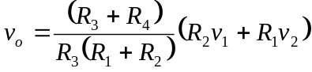

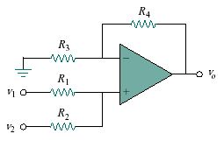
Figure 5.78
For Prob. 5.44.

